Simple Programs Using JavaScript 1.Sorting in descending order based on salary:

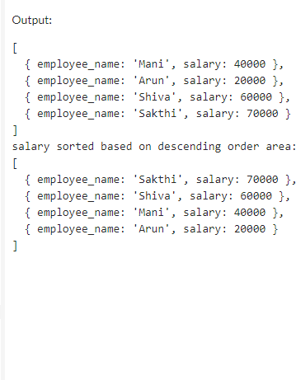

1. Removing all the numbers using regular expression:

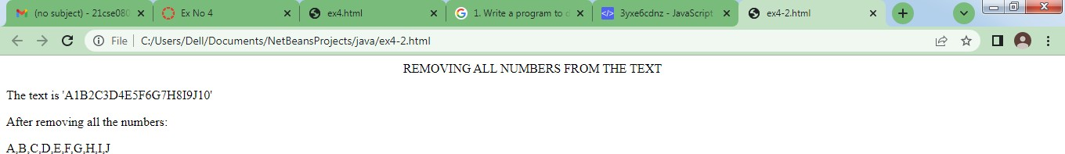

1. Adding new! before string or returning the same string if it already starts with new!:

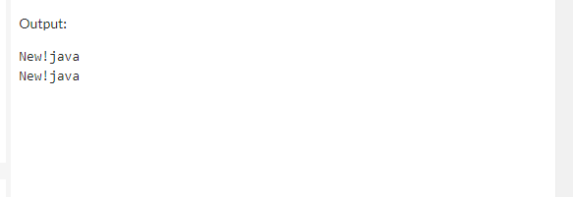

1. CSV to 2D array:

